2/9/2018

The Design and Innovation of Turbochargers

Project 1

Zach Moyse

Design of Elements

For many years, car manufacturers have struggled to produce engines with large power outputs while still adhering to the various emissions standards. To solve this problem, manufactures looked to improve the auto cycle. We are going to look at one of the most common forced induction devices, the turbocharger. Its purpose is simple, increase power and efficiency.

The turbocharger has been around for almost as long as the internal combustion engine. The first turbos were first experimented with in 1885 and 1886 by Gottlieb Daimler and Rudolf Diesel. In 1925, the Swiss engineer Alfred Büchi was the first to successfully turbocharge an engine and was able to achieve a power increase of more than 40 %. [1]. Then in 1938, the first diesel engine was produced with a turbocharger. From that point on, engine manufactures have been using turbocharger to improve their engines.

So how does the turbocharger improve the engine. Well even back in the late 1800’s, engineers knew that the internal combustion engine was not perfectly efficient. One way to improve the auto cycle is to have more air in the cylinder so the gas can burn more completely. With the increase in air density there can also be an increase in fuel in the cylinder which leads to more power. The turbocharger fulfills the need for more air flow by using a small turbine that is powered by the exhaust from the engine to intern power a compressor. The compressed air is forced into the cylinder to make the engine more efficient.

In terms of usability, who is going to buy this product and why would they choose a turbocharger instead of another device. One reason is that turbochargers are excellent for making large amounts of power. Since the exhaust powers the compressor, the engine does not loss any power from running it. This makes turbocharging particularly interesting for high performance applications. Companies like Koenigsegg, Mclaren, and Mercedes-Benz who want to make big power reliably need a way to increase air density in the engine without having compression ratios that will make the engine misfire or “knock”. With the turbo, you can drop the compression ratio a little and increase air density. This way you are less likely to have engine knock while operating at high engine speeds. In other applications, turbo’s can be used to significantly downsize the engine to increase efficiency while still maintaining the desired amount of power. Ford, Toyota, and Volkswagen are examples of companies that use turbos to increase the overall efficiency of their engines. This also allows for engine weight to be reduced making the car even more efficient. For both cases, reliability is a very important part of using this device. Under normal operations a turbocharger should last for the lifetime of the engine. However, turbos are not perfect and failure can occur from foreign object impact and lack of lubrication.

To further understand this mechanism, we must understand what makes up the system. In general, turbochargers are comprised of two turbo-houses, two turbine fans, one shaft, and a center housing assembly.

First, we are going to look at the center housing of the turbo. This assembly is in between the exhaust turbine housing and the compressor housing. [5] Its main purpose is to hold the bearings and shaft in a lubricated environment separate from the high temperature regions of the device. There are many different types of bearing that can be used, but some of the most common types are journal bearing and thrust bearings. One of each is attached to either end of the shaft to support the shaft as it rotates at high velocity. The bearings are typically made of M2 high speed steel which is an alloy of steel that utilizes tungsten and molybdenum. [3]. The shaft that connects the exhaust fan to the compressor fan is made of forged steel. These high-quality materials are needed in this assembly to withstand operating temperatures of about 200°C and shaft rotation speeds of up to 250,000 rpm. [5]

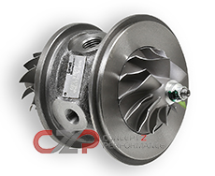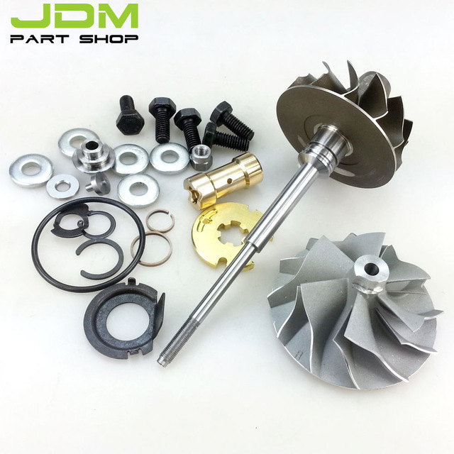

The fully assembled central housing is shown in the first image on the left. It contains all the components in image 2 and protects them from foreign debris. The parts in image 2 feature high levels of finish and precision in order to operate at the materials max capacity.

The two turbine houses are crucial parts in the overall assembly of the turbocharger. There are two housings, one on each side of the central housing assembly, each designed for a different purpose. The exhaust housings purpose is to channel high velocity exhaust gases into its core to power the exhaust turbine. On the other side, the compressor housing channels compressed intake air into the engines intake manifold. Both of these housings are subject to extreme pressures and temperatures so it must be made of high quality materials such as stainless stress alloys. Another important aspect of the housing is the quality of finish on the inside channel surfaces. Since there is high pressure and velocity gases flowing through the channels, all the internal surfaces must have high levels of finish to ensure the highest flow rates. To do this, manufactures cast the housing using sand molds and then machine the surfaces to within thousandths of a millimeter. This high level of precision allows for less turbulence and higher flow rates.

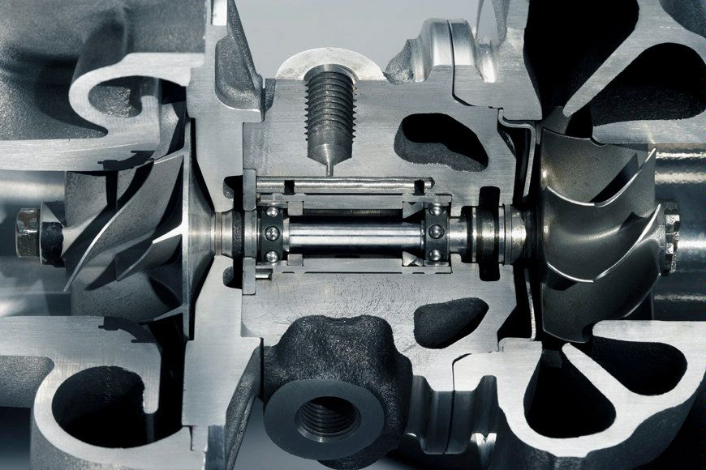

This image shows a cut away section of the turbocharger assembly. On the left, you can see the compressor wheel that is resting inside the compressor housing.

Finally, there are two turbine fans that are connected to the shaft and rest inside the turbine housings. These fans are made of different alloy material because they are subject to different forces and temperatures. The exhaust fan is subject to temperature in excess of 1050°C and high radial forces. To withstand these stresses while still remaining light weight, manufactures use special materials like the Mar-M super alloy. The compressor fan is also subject to high temperatures and pressures but not to the same degree as the turbine wheel. The compressor blades are made of stainless steel or another type of forged steel. This allows the blades to be lightweight while still remaining rigid at over 200°C. These alloys are crucial to the construction of the turbo. Using this material ensures that the turbine wheel will not fail due to thermal stress at extreme operating temperatures.

As far as engine components go, turbocharger operate at some of the highest temperatures. All of the components in the assembly undergo drastic temperature changes over the devices lifetime. In this way, most of the components are subject to thermal stress. The components that are subject to high thermal effects are the Exhaust fan, Turbine housing, Compressor Fan, and Compressor housing. Since the device can generate extreme temperatures the parts must be able to withstand heating and cooling cycles. These temperatures can vary from -20°C up to 1050°C. The turbo housing and the blades expand and contract during these heat cycles.

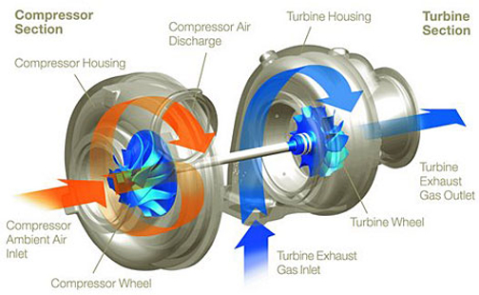

Knowing the various parts, we can better understand the forces and operating functions of the turbo. During normal operation of a turbocharged engine, exhaust gas in excess of 950°C is produced by the engine and is piped into the intake manifold of the exhaust housing. The aerodynamics of the blade allow for radial forces from the gas to rotate the turbine and force the exhaust gases out of housing towards the tail pipe. As the pressure increases inside the turbine housing, the turbines rotational speed increases and in turn rotates the compressor blades. Because of the different aerodynamics of the compressor blades, the rotation of the fan pulls in ambient air at the intake. This high velocity, low pressure air is compressed to low velocity, high pressure air inside the compressor housing. The compressed air is then channeled to the engines intake to be mixed with fuel and injected into the cylinder. [5]

As you can see, turbocharges are an innovative solution to optimize the internal combustion engine. Unlike other solutions, the turbocharger does not take power away from the engine in order for it to operate. As perfect as this system may seem, a standard model has a few shortcomings. One example is turbo lag. Turbo lag is when the engine demands more compressed air than the turbo can produce at that moment. This tends to occur when you try to accelerate quickly at low engine rpms. Since the turbo was rotating at low rpm it is not compressing a lot of air, and it takes time for the exhaust gas to build up pressure to rotate the exhaust turbine. Depending on the size of the turbo it will spool up at different rates. There are small turbines that are able to spool up at lower engine rpms but reach their max rpm before the engine reaches max rpm. There are also large turbines with larger air capacities to continue to max power till the engine hits its max rpm, but the turbine takes longer to spool up. [5]

Turbochargers have a cleaver design because it works to optimize the internal combustion engine without pulling power from it. Unlike other solutions, the turbocharger uses the exhaust gases that would otherwise be wasted and uses it to improve the efficiency of the engine. Over many years, the turbocharger has been improved to improve function and reliability. One major improvement that has recently come out is variable geometry turbochargers. These models feature movable veins on the inside of turbine housing.

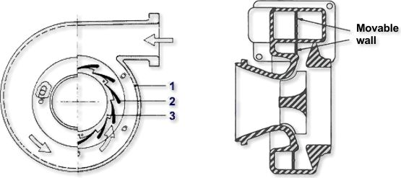

At low engine speeds, the veins rotate so there is a small area that the exhaust can flow into. This increases pressure and rotates the exhaust blade more quickly. As a result, the turbo has very little lag time and produces more power at lower engine speeds. Once the engine is operating at high rpm, the veins are able to open, giving the turbo housing a larger capacity. This allows for the turbo to continue to produce power throughout the rev range of the motor. This new design allows one turbo to behave like a large and small capacity turbo. [8]

After looking at standard turbocharges and a variable geometry solutions it is clear that turbochargers are the best solution to engine power and efficiency increases. Even though the standard model is not perfect, new solution are continuing to appear. Eventually there might not be any down sides to turbocharging an engine. With less wasted energy and an increase in performance turbos are a clear choice.

Sources:

[1] Systems, BorgWarner Turbo. “History.” *BorgWarner Turbo Systems*, 2000, www.turbos.bwauto.com/products/turbochargerHistory.aspx.

[2] Gunter, Edgar J, and Wen Jeng Chen. “DYNAMIC ANALYSIS OF A TURBOCHARGER IN FLOATING BUSHING BEARINGS.” dyrobes.com/wp-content/uploads/2012/12/Dynamic-Analysis-of-a-Turbocharger-in-Floating-Bushing-Bearings-ISCORMA3-Gunter-Chen-2005.pdf.

[3] “M2 High Speed Steel.” *High Speed Steel | M2 High Speed Steel | M2 Steel*, Hudson, 2018, www.hudsontoolsteel.com/technical-data/steelM2.

[4] “Garrett GT4202R Ball Bearing Turbocharger 774595-X.” *Empire Performance Engineering*, Garret, 2016, empire-performance.com/garrett-gt4202r-ball-bearing-turbocharger-774595-x.php.

[5] Inc., Jack Kane; EPI. “- Turbochargers -.” *Turbochargers: How They Work, and Current Turbo Technology, by EPI Inc.*, EPI Inc., 5 May 2017, www.epi-eng.com/piston_engine_technology/turbocharger_technology.htm.

[6] AZoM, Written by. “Super Alloy Mar M 247™.” *AZoM.com*, AZO Materials, 11 July 2013, www.azom.com/article.aspx?ArticleID=7808.

[7] Maziasz, Philip J. “Materials for Advanced Turbocharger Design.” *Energy.gov*, energy.gov/sites/prod/files/2014/03/f10/pm038_maziasz_2012_o.pdf.

[8] Jääskeläinen, Hannu. “Variable Geometry Turbochargers.” *Variable Geometry Turbochargers*, Aug. 2016, www.dieselnet.com/tech/air_turbo_vgt.php.